Exception Handling

Electricity Bill Calculation with Exception Handling‬

●

‬

●

‬

●

‬

●

‬

●

‬

●

‬

○

‬

○

‬

○

‬

○

‬

○

‬

Ans:

import java.util.InputMismatchException;

import java.util.Scanner;

class ElectricityBill {

private String customerName;

private double unitsConsumed;

private double billAmount;

public ElectricityBill(String customerName, double unitsConsumed) {

this.customerName = customerName;

if (unitsConsumed < 0) {

throw new IllegalArgumentException("Units consumed cannot be negative.");

}

this.unitsConsumed = unitsConsumed;

}

public void calculateBillAmount() {

if (unitsConsumed <= 100) {

billAmount = unitsConsumed \* 5;

} else if (unitsConsumed <= 300) {

billAmount = 100 \* 5 + (unitsConsumed - 100) \* 7;

} else {

billAmount = 100 \* 5 + 200 \* 7 + (unitsConsumed - 300) \* 10;

}

}

public double getBillAmount() {

return billAmount;

}

// Method to get the customer name

public String getCustomerName() {

return customerName;

}

public double getUnitsConsumed() {

return unitsConsumed;

}

}

public class ElectricityBillCalculator {

public static void main(String[] args) {

Scanner scanner = new Scanner(System.in);

System.out.print("Enter customer name: ");

String customerName = scanner.nextLine();

// Handle exceptions for invalid input

double unitsConsumed = 0;

while (true) {

try {

System.out.print("Enter units consumed: ");

unitsConsumed = scanner.nextDouble();

if (unitsConsumed < 0) {

throw new IllegalArgumentException("Units consumed cannot be negative.");

}

// Valid input, exit the loop

break;

} catch (InputMismatchException e) {

System.out.println("Invalid input! Please enter a numeric value for units consumed.");

scanner.nextLine(); // Clear the buffer

} catch (IllegalArgumentException e) {

System.out.println(e.getMessage());

scanner.nextLine(); // Clear the buffer

}

}

// Create ElectricityBill object and calculate the bill

ElectricityBill bill = new ElectricityBill(customerName, unitsConsumed);

bill.calculateBillAmount();

// Display the result

System.out.println("\n--- Bill Details ---");

System.out.println("Customer Name: " + bill.getCustomerName());

System.out.println("Units Consumed: " + bill.getUnitsConsumed());

System.out.println("Total Bill Amount: Rs. " + bill.getBillAmount());

}

}

Output:

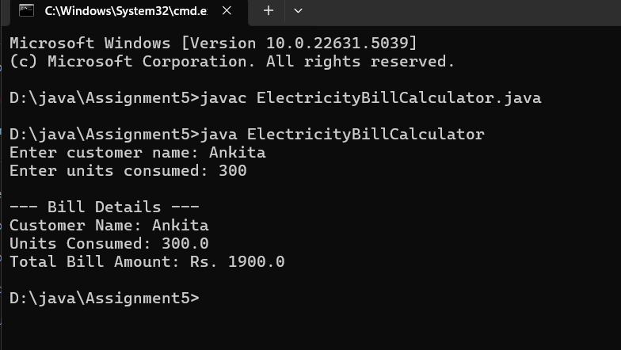

Qution 02: Design a Java program to calculate the total marks, average, and grade of a student, with‬‬

●

‬

●

‬

●

‬

●

‬

●

‬

●

‬

●

‬

●

‬

●

○

‬

○

‬

○

‬

○

‬

○

‬

●

‬

‬

○

‬

○

‬

Ans:

import java.util.Scanner;

import java.util.InputMismatchException;

class Student {

private String name;

private int rollNo;

private double[] marks = new double[5];

private double average;

private char grade;

public Student(String name, int rollNo, double[] marks) {

if (marks.length != 5) {

throw new IllegalArgumentException("There must be exactly 5 marks.");

}

for (double mark : marks) {

if (mark < 0 || mark > 100) {

throw new IllegalArgumentException("Marks should be between 0 and 100.");

}

}

this.name = name;

this.rollNo = rollNo;

this.marks = marks;

}

public void calculateAverage() {

double total = 0;

for (double mark : marks) {

total += mark;

}

average = total / marks.length;

}

public void calculateGrade() {

if (average >= 90) {

grade = 'A';

} else if (average >= 80) {

grade = 'B';

} else if (average >= 70) {

grade = 'C';

} else if (average >= 60) {

grade = 'D';

} else {

grade = 'F';

}

}

public void displayStudentInfo() {

System.out.println("Student Name: " + name);

System.out.println("Roll Number: " + rollNo);

System.out.print("Marks: ");

for (double mark : marks) {

System.out.print(mark + " ");

}

System.out.println();

System.out.println("Average Marks: " + average);

System.out.println("Grade: " + grade);

}

public static void main(String[] args) {

Scanner scanner = new Scanner(System.in);

try {

System.out.print("Enter student name: ");

String name = scanner.nextLine();

System.out.print("Enter roll number: ");

int rollNo = scanner.nextInt();

double[] marks = new double[5];

System.out.println("Enter marks for 5 subjects:");

for (int i = 0; i < 5; i++) {

marks[i] = scanner.nextDouble();

}

Student student = new Student(name, rollNo, marks);

student.calculateAverage();

student.calculateGrade();

student.displayStudentInfo();

} catch (InputMismatchException e) {

System.out.println("Invalid input. Please enter valid numeric values for roll number and marks.");

} catch (IllegalArgumentException e) {

System.out.println(e.getMessage());

} finally {

scanner.close();

}

}

}

Output:

